ST. XAVIER’S COLLEGE

**Maitighar, Kathmandu**



**Computer Graphics**

**Lab Assignment #3**

**SUBMITTED BY:**

**Siddhant Rimal**

**013BSCCSIT039**

**SUBMITTED TO**

|  |  |
| --- | --- |
| **Er. Anil Sah**  **( Lecturer )** |  |
| **Department of Computer Science** | |

Submission Date: August 14th 2015

**OBJECTIVE 1.1: TO PLOT A LINE WITH DDA ALGORITHM**

|  |  |
| --- | --- |
| **Algorithm:** | |
| Step 1 | Start |
| Step 2 | Input a,b,and d |
| Step 3 | dx=c-a |
|  | dy=d-b |
| Step 4 | if if(abs(dx)>abs(dy)) |
| Step 5 | steps=abs(dx); |
|  | else |
|  | steps=abs(dy); |
| Step 6 | incrx=dx/steps; |
|  | incry=dy/steps; |
| Step 7 | x=a; |
|  | y=b; |
| Step 8 | Image1->Canvas->Pixels[x][y]=RGB(150,100,125); |
|  |  |
| Step 9 | If k<=steps |
| Step 10 | x=x+incrx; |
|  | y=y+incry; |
| Step 11 | Image1->Canvas->Pixels[x][y]=RGB(150,100,125); |
| Step 12 | Increase k |
| Step 13 | Stop |

|  |
| --- |
| **Source Code:** |
| //--------------------------------------------------------------------------- |
| #include <vcl\vcl.h> |
| #pragma hdrstop |
|  |
| #include "dda.h" |
| //--------------------------------------------------------------------------- |
| #pragma resource "*.dfm" |
| TForm2 *Form2; |
| int X,Y; |
| int slope,dx,dy,x1,y1,x2,y2,n,nc; |
| //--------------------------------------------------------------------------- |
| __fastcall TForm2::TForm2(TComponent* Owner) |
|  |
| { |
|  |
| } |
| //--------------------------------------------------------------------------- |
| void __fastcall TForm2::Button1Click(TObject *Sender) |
| { |
| x1=StrToInt(X1->Text); |
| x2=StrToInt(X2->Text); |
| y1=StrToInt(Y1->Text); |
| y2=StrToInt(Y2->Text); |
| dy=y2-y1; |
| dx=x2-x1; |
| slope=dy/dx; |
|  |
| if (dx>dy) |
| { |
| n=dx; |
| } |
| else |
| { |
| n=dy; |
| } |
| Y=y1; |
| X=x1; |
| do{ |
| Image1->Canvas->Pixels[X][Y]=RGB(0,0,255); |
| if (slope<=1) |
|  |
| Y=Y+slope; |
| X=X+1; |
|  |
| else |
|  |
| X=X+1/slope; |
| Y=Y+1; |
| } |
| nc++; |
| }while(nc<=n); |
| } |
| //--------------------------------------------------------------------------- |

**OUTPUT:**

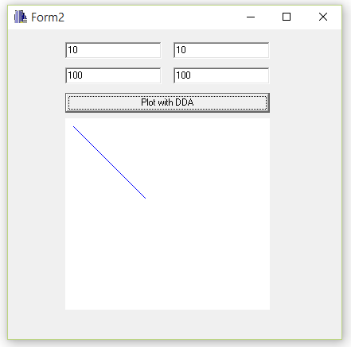

Fig: Plotting Line with DDA Algorithm

**CONCLUSION:**

The program could plot a simple line following the DDA algorithm. The program needs X1,Y1, X2 and Y2 co-ordinate values to operate.